Power BI Notes :
1. Introduction to Power BI
- Power BI is a business analytics tool by Microsoft that helps visualize data and share insights.
- Components:
  - Power BI Desktop – For creating reports and dashboards.
  - Power BI Service – Cloud service for sharing and collaboration.
  - Power BI Mobile – View reports on mobile devices.
  - Power BI Report Server – On-premises report publishing.
- Key Features:
  - Connects to multiple data sources (Excel, SQL, Azure, APIs, etc.).
  - Data modeling and transformations (Power Query & DAX).
  - Interactive visualizations and dashboards.
  - Scheduled refresh and row-level security (RLS).
  - AI visuals and Q&A (natural language queries).
2. Power BI Workflow
- Connect to Data – Import or connect live to data sources.
- Transform Data – Clean, filter, merge using Power Query.
- Model Data – Create relationships, hierarchies, and calculated columns/measures.
- Visualize Data – Build charts, tables, maps, and dashboards.
- Share & Collaborate – Publish reports to Power BI Service.
3. Data Sources
- Excel & CSV
- SQL Server / Database connections
- Azure Data Lake / Azure SQL
- SharePoint Lists
- Web / APIs
- Other Services: Salesforce, Dynamics 365, Google Analytics, etc.
4. Power Query (Data Transformation)
- Key Functions:
  - Remove columns/rows
  - Filter data
  - Merge queries (JOINs)
  - Append queries (UNION)
  - Pivot & Unpivot
  - Change data types
  - Conditional columns
  - Split columns
  - Fill up/down
5. Data Modeling in Power BI
1. What is Data Modeling?
Data modeling in Power BI is the process of structuring data to define how different tables relate to each other.
It helps Power BI understand how to combine data from multiple sources and allows you to perform calculations (like totals, averages, or comparisons) accurately using DAX.
2. Relationships
Relationships connect tables using common columns (keys).
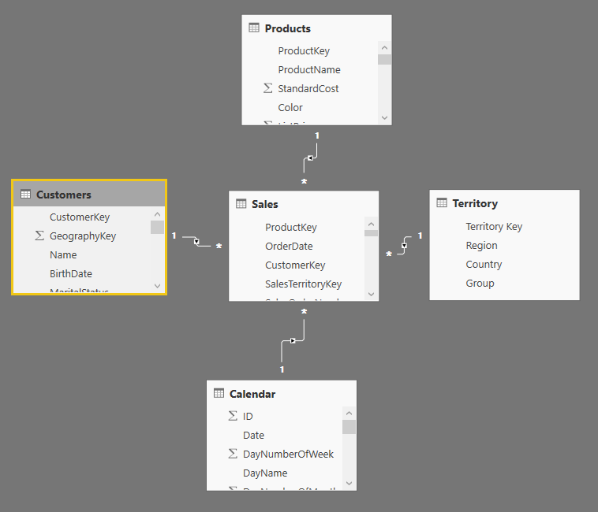
Types of Relationships:
Type | Symbol | Description | Example
One-to-Many (1:*) | 1:* | One value in one table relates to many in another. | One Customer ID → many Orders
Many-to-One (*:1) | *:1 | Reverse of One-to-Many; used when connecting a fact table to a dimension table. | Many Sales Rows → one Product
Many-to-Many (:) | : | When both tables have non-unique values. Needs a bridge/intermediate table. | Students ↔ Courses (many students can join many courses)

Cardinality
- Cardinality defines the uniqueness of data between tables.
- It impacts DAX functions like CALCULATE(), RELATED(), and context propagation.
Cross Filter Direction
- Single: Filters flow in one direction (usually from dimension → fact table).
- Both: Allows filters to flow both ways; used in complex models.
3. Keys in Data Modeling
Key Type | Description | Example
Primary Key | A unique identifier in a table (no duplicates). | CustomerID in Customer table
Foreign Key | A reference to a primary key in another table. | CustomerID in Orders table links to Customer table
The relationship is built on matching Primary Key ↔ Foreign Key.
4. Star Schema vs Snowflake Schema
Star Schema
- Structure:
  - 1 Fact Table (contains numeric, measurable data — like sales, revenue, quantity)
  - Multiple Dimension Tables (contain descriptive attributes — like customer name, product category, date)
- Simple and Fast
- Easy to visualize relationships
- Best for Power BI performance

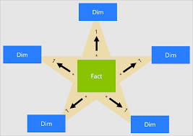

Snowflake Schema
- Extension of star schema.
- Dimension tables are normalized (split into sub-tables).
- More complex → slower performance.
Use Case: When dimension tables are large and repeated data must be avoided.

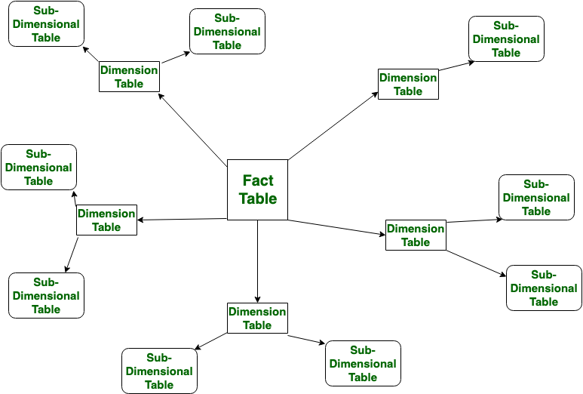
5. Fact and Dimension Tables
Table Type | Contains | Example Columns | Example
Fact Table | Quantitative data (measures) | SalesAmount, Quantity | Sales
Dimension Table | Descriptive attributes | CustomerName, ProductName | Customer, Product

6. Example Relationship Setup
Tables:
- Sales (Fact): OrderID, CustomerID, ProductID, Amount
- Customer (Dimension): CustomerID, Name, City
- Product (Dimension): ProductID, ProductName, Category
Relationships:
- Customer[CustomerID] → Sales[CustomerID] (1:*)
- Product[ProductID] → Sales[ProductID] (1:*)
Now you can use DAX functions like:
. Best Practices for Data Modeling
Use Star Schema whenever possible.
Create unique keys for each table.
Avoid many-to-many relationships unless required.
Define clear relationship directions (usually single).
Remove unused columns and ensure proper data types.
Keep fact tables wide (more measures) and dimension tables long (more rows).

6. DAX (Data Analysis Expressions)
Purpose:
Used to create calculated columns, measures, and calculated tables in Power BI for advanced analysis and dynamic calculations.
Basic Functions:
Function | Description | Example
SUM() | Returns the total of a numeric column. | SUM(Sales[Amount])
AVERAGE() | Returns the mean of a numeric column. | AVERAGE(Sales[Profit])
COUNT() | Counts numeric values only. | COUNT(Sales[Quantity])
COUNTA() | Counts all non-blank values. | COUNTA(Customer[Name])
COUNTROWS() | Counts the number of rows in a table. | COUNTROWS(Sales)
MAX() / MIN() | Returns the highest/lowest value. | MAX(Sales[Amount])

Logical Functions:
Function | Description | Example
IF() | Checks a condition and returns a value if true or false. | IF(Sales[Profit] > 0, "Profit", "Loss")
SWITCH() | Replaces multiple IFs, checks against multiple cases. | SWITCH(TRUE(), [Score] >= 90, "A", [Score] >= 80, "B", "C")

Filter Functions:
Function | Description | Example
CALCULATE() | Changes the filter context to perform dynamic calculations. | CALCULATE(SUM(Sales[Amount]), Region[Name] = "East")
FILTER() | Returns a filtered table that can be used inside CALCULATE. | FILTER(Sales, Sales[Amount] > 1000)

Time Intelligence Functions:
Function | Description | Example
TOTALYTD() | Calculates year-to-date values. | TOTALYTD(SUM(Sales[Amount]), Date[Date])
SAMEPERIODLASTYEAR() | Compares data from the same period last year. | CALCULATE(SUM(Sales[Amount]), SAMEPERIODLASTYEAR(Date[Date]))
DATEADD() | Shifts dates by a specific interval (days, months, years). | CALCULATE(SUM(Sales[Amount]), DATEADD(Date[Date], -1, YEAR))

Measure vs Calculated Column
Feature | Measure | Calculated Column
Calculation Type | Calculated on the fly (runtime) | Calculated row-by-row
Storage | Not stored in table | Stored in table
Performance | Faster (less memory) | Slower (more memory)
Context | Filter context | Row context
Usage | Used in visuals, cards, KPIs | Used in data model relationships or filters
7. CHART AND VISUALIZATION
1. Clustered Column Chart
Definition: A chart that displays data with vertical bars grouped by category to compare values side by side.
X-Axis: Categories (e.g., Product, Region)
Y-Axis: Numeric values (e.g., Sales, Profit)
Legend: Optional (e.g., Year)
Use: Compare values across categories side by side.
Example: Sales by Region for different years.

2. Stacked Column Chart
Definition: A vertical bar chart where values are stacked on top of each other to show parts of a whole.
X-Axis: Categories
Y-Axis: Total value (stacked by sub-category)
Legend: Sub-category (e.g., Product Type)
Use: Show contribution of each category to the total.
Example: Total sales by region, divided by product type.

3. 100% Stacked Column Chart
Definition: Displays percentage contributions of sub-categories that stack up to 100%.
X-Axis: Categories
Y-Axis: Percentage (0–100%)
Legend: Sub-category
Use: Compare percentage contribution of each sub-category.
Example: Market share percentage by brand in each region.

4. Clustered Bar Chart
Definition: A horizontal version of a clustered column chart used to compare long category names.
X-Axis: Numeric value (e.g., Sales)
Y-Axis: Categories (horizontal layout)
Legend: Optional
Use: Compare long category names horizontally.
Example: Sales by Country.

5. Stacked Bar Chart
Definition: Displays horizontal bars divided into segments representing sub-categories stacked together.
X-Axis: Total numeric value
Y-Axis: Category
Legend: Sub-category
Use: Same as stacked column but horizontal.
Example: Total sales by department (stacked by product type).

6. 100% Stacked Bar Chart
Definition: A horizontal chart showing relative percentage contributions that total 100%.
X-Axis: Percentage
Y-Axis: Category
Legend: Sub-category
Use: Compare relative percentage distribution.
Example: Customer type (New vs Returning) per region.

7. Line Chart
Definition: Displays trends over time by connecting data points with a line.
X-Axis: Continuous variable (usually Date/Time)
Y-Axis: Numeric value (e.g., Sales)
Legend: Series (e.g., Product Category)
Use: Show trend over time.
Example: Monthly revenue trend.

8. Area Chart
Definition: A line chart with the area below the line filled to emphasize volume or magnitude.
X-Axis: Time or Category
Y-Axis: Value (filled area under line)
Legend: Series
Use: Emphasize volume or total change over time.
Example: Cumulative revenue trend.

9. Stacked Area Chart
Definition: Displays cumulative totals over time by stacking multiple area series.
X-Axis: Time
Y-Axis: Stacked total values
Legend: Series (categories)
Use: Show how each category contributes over time.
Example: Sales by region over months.

10. Line and Clustered Column Chart
Definition: Combines a column and line chart to compare two related measures on shared axes.
Shared X-Axis: Category (e.g., Month)
Y-Axis (Left): Column values
Y-Axis (Right): Line values
Use: Compare two related metrics.
Example: Revenue (columns) vs Profit Margin (line).

11. Waterfall Chart
Definition: Shows how an initial value is affected by positive and negative changes leading to a final total.
X-Axis: Categories/Events
Y-Axis: Cumulative value
Use: Show how starting value changes with positive and negative values.
Example: Profit bridge from revenue to net income.

12. Scatter Chart
Definition: Plots points for two numeric variables to show relationships, patterns, or correlations.
X-Axis: Numeric variable 1
Y-Axis: Numeric variable 2
Size: Optional (e.g., sales volume)
Color/Legend: Category
Use: Show relationships and correlations.
Example: Advertising Spend vs Revenue.

13. Pie Chart
Definition: Displays proportions of a whole using slices of a circle.
Legend: Category
Values: Numeric value
Use: Show proportion of categories to a whole.
Example: Market share by company.

14. Donut Chart
Definition: A circular chart similar to a pie chart but with a hollow center to show totals or percentages.
Legend: Category
Values: Value
Use: Same as pie chart; center space can show total.
Example: % contribution of each product to total sales.

15. Map
Definition: Plots data points geographically using latitude, longitude, or region fields.
Location Field: City, Country, Lat/Long
Size: Value (bubble size)
Color: Category or value intensity
Use: Show geographic distribution.
Example: Sales by location.

16. Filled Map
Definition: Colors entire geographic areas based on data values (heat or intensity).
Location Field: Geographic area
Color Saturation: Value
Use: Show density or intensity across regions.
Example: Population density by state.

17. Shape Map
Definition: Uses custom geographic or region shapes (GeoJSON) to display value intensity.
Location Field: Custom shape/region (GeoJSON)
Color: Value intensity
Use: Custom region-based visualization.
Example: Sales by custom sales territory.
18. Card
Definition: Displays a single KPI or metric in large text format.
Value: Single number (KPI)
Use: Show a single key metric.
Example: Total Revenue = ₹1.2M

19. Multi-row Card
Definition: Displays multiple KPIs or fields in a compact, readable layout.
Fields: Multiple values
Use: Display several KPIs together.
Example: Total Sales, Profit, and Customers.

20. Table
Definition: Displays raw, detailed data in rows and columns similar to an Excel sheet.
Columns: Fields (text/numeric)
Use: Show detailed data, raw format.
Example: List of transactions with amount, date, customer.

21. Matrix
Definition: A pivot-table style visual showing summarized data across rows and columns.
Rows: Categories
Columns: Categories (like pivot)
Values: Aggregated measures
Use: Cross-tab style summary.
Example: Region (rows) × Product (columns) showing sales.

22. Decomposition Tree
Definition: A visual that breaks down a measure hierarchically to explore root causes.
Analyze Field: Main measure (e.g., Sales)
Explain By: Dimensions (Region → Product → Month)
Use: Root cause or hierarchical breakdown.
Example: Why did profit drop this month?

23. Key Influencers
Definition: An AI visual that identifies key factors influencing a selected metric.
Analyze: Dependent variable (target)
Explain By: Independent variables (factors)
Use: Find what drives changes in a metric.
Example: What influences customer churn?

24. Smart Narrative
Definition: Automatically generates text-based summaries and insights from visuals.
Inputs: Any visual/measure
Output: Auto-generated text insights
Use: Auto summaries (“Sales grew 12% vs last year”).

25. Gauge
Definition: A dial-like visual showing progress toward a specific target.
Value: KPI measure
Target: Goal value
Min/Max: Range
Use: Show performance against goal.
Example: Sales = ₹90K (Target ₹100K).

26. KPI
Definition: Shows a key metric’s performance, target, and trend direction.
Indicator: Current value
Trend Axis: Date/Time
Target: Goal value
Use: Track performance and direction (up/down).
Example: Profit margin trend vs target.

27. Slicer
Definition: An interactive filter used to control data displayed across visuals.
Field: Any category/date
Use: Add interactive filter.
Example: Filter report by Year or Product.

28. R / Python Visual
Definition: Runs custom R or Python scripts to generate advanced visuals or models.
Inputs: Data fields
Script Output: Custom chart (R or Python code)
Use: Advanced visuals and ML outputs.
Example: Regression line, clustering plot.

29. Q&A Visual
Definition: Allows users to ask natural language questions and generates dynamic visuals.
Input: Natural language question (typed)
Output: Dynamic visual answer
Use: Interactive data exploration.
Example: “Show sales by region in 2024.”

30. Power Automate Visual
Definition: Integrates with Power Automate to trigger workflows from Power BI reports.
Trigger: Button inside report
Use: Run workflow (send email, update record, etc.)
Example: Send alert when profit < target.
1. Goal (Power BI Goals in Power BI Service)
Definition:
Power BI Goals is a performance tracking feature inside Power BI Service (in “Scorecards”). It helps organizations define, track, and manage key business objectives (KPIs) in real time.
Key Features:
- Create scorecards with measurable goals and sub-goals.
- Link each goal directly to Power BI report data for live tracking.
- Supports status indicators like On Track, At Risk, or Behind.
- Enables collaboration by assigning owners and due dates.
Use:
Track business performance such as revenue targets, sales goals, or project milestones.
Example:
Track “Monthly Sales Target = ₹5,00,000” with automatic progress updates from sales reports.
2. Paginated Report
Definition:
Paginated Reports are pixel-perfect, print-ready reports in Power BI, designed for detailed layouts like invoices, statements, or forms.
They use Power BI Report Builder (RDL format) and can display large tables across multiple pages — hence the name paginated.
Key Features:
- Perfect for exporting or printing (PDF, Excel).
- Supports headers, footers, and precise layout control.
- Works well for operational reporting and financial summaries.
Use:
Generate detailed, formatted reports that can be printed or shared.
Example:
Monthly employee salary statements or customer billing reports.
3. ArcGIS for Power BI
Definition:
ArcGIS is an advanced mapping and spatial analysis visual integrated within Power BI (by Esri). It enables geographic analysis with layered map visualizations beyond the basic map visual.
Key Features:
- Add multiple layers like heat maps, reference layers, and demographic data.
- Perform spatial analysis such as clustering or drive-time areas.
- Uses Esri’s geographic intelligence for location-based insights.
Use:
Analyze data geographically to understand spatial trends or density.
Example:
Visualize store sales by region and identify high-performing areas within 10 km of a city center.
4. Power Apps Visual for Power BI
Definition:
This visual embeds a Power Apps app directly inside a Power BI report. It allows users to view, edit, or add data interactively — bridging data visualization and data entry.
Key Features:
- Integrates real-time data input into Power BI.
- Allows users to take actions (e.g., update or submit data).
- Two-way connection between Power BI and Power Apps datasets.
Use:
Enable users to edit or submit data directly within reports.
Example:
A sales dashboard where users can update deal status or add new customer details without leaving Power BI.
5. Power Automate for Power BI
Definition:
The Power Automate visual integrates Power BI with Power Automate flows (Workflows). It lets users trigger automated actions (like notifications, approvals, or updates) directly from a report.
Key Features:
- Create automated workflows triggered by button clicks or data changes.
- Send alerts, update databases, or integrate with Teams, Outlook, etc.
- Simplifies repetitive business processes.
Use:
Automate workflows from Power BI insights.
Example:
When profit < target, send an automatic email alert to the finance manager.
6. Decomposition Tree (AI Visual)
Definition:
An AI-powered visual in Power BI that breaks down a measure (like Sales or Profit) into hierarchical components to explore root causes or detailed analysis.
Key Features:
- Interactive drill-down analysis.
- AI can automatically suggest the next best dimension for analysis.
- Useful for why-analysis and performance breakdowns.
Use:
Identify the reasons behind an increase or decrease in key metrics.
Example:
Break down “Profit” → by “Region” → “Product Category” → “Month” to find where losses occurred.

7. Key Influencers (AI Visual)
Definition:
An AI visual that identifies factors influencing a target metric by analyzing relationships between variables.
Key Features:
- Uses machine learning to detect which fields affect your outcome most.
- Displays key drivers and their impact direction (positive/negative).
- Helps in predictive or diagnostic analysis.
Use:
Find what impacts a specific result, like customer satisfaction or churn.
Example:
“What influences customer churn?” → Subscription duration and support quality might be top influencers.

8. Smart Narrative (Narrative Visual)
Definition:
Automatically generates text-based insights and summaries from your visuals and measures. It uses natural language generation to explain data trends and key points.
Key Features:
- Converts visuals into readable summaries.
- Dynamically updates when underlying data changes.
- Provides quick data storytelling without manual writing.
Use:
Summarize dashboards automatically with textual explanations.
Example:
“Total Sales increased by 12% compared to last month, mainly driven by North Region performance.”
8. Filters & Slicers
Purpose:
Filters and slicers are used to refine and focus data in reports. They help control what data is displayed in visuals.
1. Visual-Level Filter
- Applies to: A single visual only.
- Use Case: When you want to show data for a specific product, region, or category in one chart without affecting others.
- Example:
A bar chart shows sales only for “Electronics,” while the rest of the page shows all categories.
2. Page-Level Filter
- Applies to: All visuals on the same report page.
- Use Case: When you want to view a specific subset of data (e.g., year 2024) across all visuals on that page.
- Example:
Filtering the page to show only “North Zone” sales—every chart updates accordingly.
3. Report-Level Filter
- Applies to: The entire report (all pages).
- Use Case: When you want every visual and page to focus on the same filtered dataset.
- Example:
Filtering the whole report to show only “Active Customers.”
4. Slicers
- Definition:
Visual elements that allow end users to interactively filter data by clicking or selecting values.
- Purpose:
Give users control to dynamically change what data is shown in visuals.
Types of Slicers:
- List Slicer:
  - Displays all items vertically.
  - Example: Select one or multiple product names.
  - Best for: Few items.
- Dropdown Slicer:
  - Collapsible version of list slicer.
  - Best for: Many items; saves space.
- Date Slicer:
  - Allows filtering by date range.
  - Example: Show sales from 1-Jan-2024 to 30-Jun-2024.
- Relative Date Slicer:
  - Filters data based on dynamic time ranges.
  - Example: “Last 7 days,” “Last 1 month,” “Next quarter.”
- Hierarchy Slicer:
  - Enables filtering across multiple levels (e.g., Year → Quarter → Month → Day).
  - Example: Drill down from “2023” → “Q4” → “December.”
9. Row-Level Security (RLS)
Purpose:
- Restrict data access so that users see only the data relevant to them.
- Ensures confidentiality and role-based access within the same report.
Steps to Implement RLS
- Create Roles in Power BI Desktop
  - Go to Modeling → Manage Roles.
  - Create roles like Sales_Manager, Regional_Head, or Employee.
  - Each role represents a group of users with similar data access needs.
- Define DAX Filter for Role
  - Apply a DAX expression to filter rows for each role.
  - Example:
  - [Region] = "North"
This ensures that users in the North role see only North region data.
  - You can also use dynamic filtering with USERNAME() or USERPRINCIPALNAME() to filter data per logged-in user:
  - [UserEmail] = USERPRINCIPALNAME()
- Publish Report → Assign Users in Power BI Service
  - Publish the PBIX file to Power BI Service.
  - Go to Dataset → Security.
  - Assign actual users or groups to each role.
  - When users open the report, they see only the rows defined by their assigned role.
Tips:
- Test roles in Power BI Desktop:
Modeling → View as Role to simulate what users will see.
- Combine RLS with slicers and filters for enhanced control.
- Dynamic RLS using DAX is better for large organizations with many users.

10. Power BI Service
Purpose:
- Power BI Service is the cloud-based platform for sharing, collaborating, and managing Power BI reports and dashboards.

Key Components
- Workspaces
  - Collaborative environment for teams or projects.
  - Users can create, edit, and manage reports, datasets, and dashboards together.
  - Example: Marketing team workspace for all campaign reports.
- Apps
  - Packaged collection of reports and dashboards that can be shared with end users.
  - Easier to distribute insights without giving edit access.
  - Example: Sales Performance App for managers.
- Dashboards
  - Single-page, interactive view combining visuals from multiple reports.
  - Allows quick insights and monitoring of KPIs.
  - Example: CEO dashboard showing sales, revenue, and customer metrics from different reports.
- Data Gateway
  - Bridges on-premises data sources with Power BI Service.
  - Enables refreshing data from local databases without moving the data to the cloud.
  - Types:
    - Personal Gateway: For individual use.
    - Enterprise Gateway: For multiple users/teams.
- Scheduled Refresh
  - Automatically updates datasets and dashboards at set intervals.
  - Ensures real-time or near real-time data is visible in reports.
  - Example: Refresh daily at 6 AM to show yesterday’s sales data.

